**Name:** Sairam Reddy **Registration number:** 20BRS1252

Week 3 Assignment on JDBC (Intermediate Java)

We will be creating a table using Java Database Connectivity (JDBC) and then insert some values in that table and finally display the table.

1. **Creating a table StudentDetails with attributes FirstName, LastName, RollNo, Marks.**

package javalearning;

import java.sql.* ;

import java.util.* ;

public class JDBCExample {

public static void main (String[] args) {

try {

Connection con = DriverManager.getConnection("jdbc:mysql://localhost:3306/mydb", "root", "EnwK125*" );

Statement stmt = con.createStatement() ;

String sql = "create table student_details ( firstname varchar(20), lastname varchar (20), rollno integer, marks integer );" ;

stmt.executeUpdate (sql) ;

con.close();

}catch (Exception e) {

System.out.println (e) ;

}

}

}

**Output:**

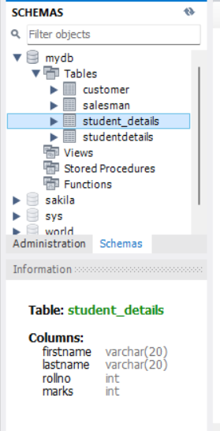

1. **Inserting values into the created table.**

package javalearning;

import java.sql.* ;

import java.util.* ;

public class JDBCExample {

public static void main (String[] args) {

try {

Connection con = DriverManager.getConnection("jdbc:mysql://localhost:3306/mydb", "root", "EnwK125*" );

PreparedStatement ps1, ps2, ps3, ps4 ;

ps1 = con.prepareStatement("insert into student_details values (?,?,?,?)");

ps1.setString(1, "sairam" ) ;

ps1.setString(2, "reddy") ;

ps1.setInt(3, 21) ;

ps1.setInt(4, 86) ;

int count1 = ps1.executeUpdate();

ps2 = con.prepareStatement("insert into student_details values (?,?,?,?)");

ps2.setString(1, "steve" ) ;

ps2.setString(2, "rogers") ;

ps2.setInt(3, 1) ;

ps2.setInt(4, 100) ;

int count2 = ps2.executeUpdate();

ps3 = con.prepareStatement("insert into student_details values (?,?,?,?)");

ps3.setString(1, "tony" ) ;

ps3.setString(2, "stark") ;

ps3.setInt(3, 2) ;

ps3.setInt(4, 99) ;

int count3 = ps3.executeUpdate();

ps4 = con.prepareStatement("insert into student_details values (?,?,?,?)");

ps4.setString(1, "bucky" ) ;

ps4.setString(2, "barnes") ;

ps4.setInt(3, 3) ;

ps4.setInt(4, 98) ;

int count4 = ps4.executeUpdate();

System.out.println (count1 + " " + count2 + " " + count3 + " " + count4) ;

con.close();

}catch (Exception e) {

System.out.println (e) ;

}

}

}

1. **Display the table.**

package javalearning;

import java.sql.* ;

import java.util.* ;

public class JDBCExample {

public static void main (String[] args) {

try {

Connection con = DriverManager.getConnection("jdbc:mysql://localhost:3306/mydb", "root", "EnwK125*" );

Statement stmt = con.createStatement();

ResultSet rs = stmt.executeQuery("select * from student_details") ;

while (rs.next()) {

System.out.println (rs.getString (1) + " " + rs.getString(2) + " " + rs.getInt(3) + " " + rs.getInt(4) ) ;

}

System.out.println("table displayed! ");

con.close();

}catch (Exception e) {

System.out.println (e) ;

}

}

}

**Output:**

